Low Level Design

Project Code | Group 3
Project Name | Expense Management System

Prepared / Modified by | Role | Date of preparation/ Modification
Group 3 | Analyst | 29-Aug-2018
Reviewed by | Role | Date of review
Approved by | Role | Date of Approval
Circulation List | kavya.lekhana-gurramkonda@capgemini.com  amruta.deokar@capgemini.com  ranjith.vallambhatla@capgemini.com  sejal.jain@capgemini.com  karan.upenja@capgemini.com  manasa.paidi@capgemini.com  rupesh.vishwakarma@capgemini.com  anshu.kumawat@capgemini.com | Version Number : 1.0
Version number of the work product | Version 1.0

Table of Contents

1. Description Of The Unit 3
2. References 4
3. Dependencies / Assumptions 5
4. Class Diagrams 6
5. Sequence Diagrams 7
6. Design Components 8
6.1 List of UI Components…….………………………………………….…………………………………8
6.2 List of Design Classes…………………………………………………………………………………….10

7. Reusable Routines/Components……………………………………………………. 11
8. Messages 12
9. Configuration Files 13
10. Crud Matrix Table 14
11. Data Mapping Matrix 15
12. Action Flow Matrix 16
13. Stored Procedures 17
14. Program Specification / Pseudo Code 18
REVISION HISTORY OF THE WORK PRODUCT 21
Description Of The Unit

This module is aimed to delete an expense code details from the database. In this module user is asked to enter an expense code on the basis of which specific expense code details gets deleted. If user enters a wrong expense code or any invalid input then system will show an error message.

Administrator should be able to

- Insert Expense Code Information
- Retrieve Expense Code Information
- Update Expense Code Information
- Delete Expense Code Information
- Retrieve all Expense Code Information

References

Reference | Description
Class Diagram | D:\Expense_Code\PLP Documents\ProjectDocuments\DesignDocuments\HLD\Class Diagram\ExpenseCodeClassDiagram.png
URS | D:\Users\kagurram\Desktop\Expense_Code\Expense_Code\PLP Documents\ProjectDocuments\Requirements\CaseStudy\ExpenseManagementSystemCaseStudy.doc
UTP | D:\Expense_Code\PLP Documents\Testing\UTP\Test_Case_ExpenseCode_deleteExpenseCode.xls
DB Design | D:\Expense_Code\PLP Documents\ProjectDocuments\DesignDocuments\HLD\DB Design\Expense_Mangement_Group_3DBDesign.xls

Dependencies / Assumptions
Dependencies:
NA

Assumptions:
The expense code details are stored in the MySQL database.

Class Diagrams
Class Diagram

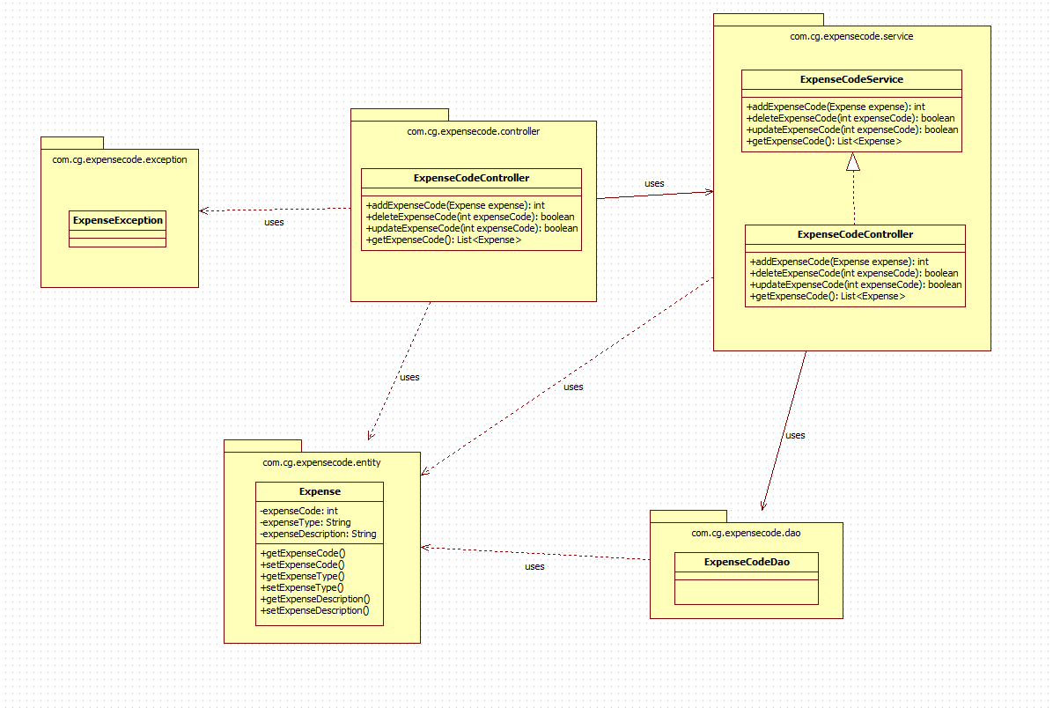

Sequence Diagrams

Sequence Diagram

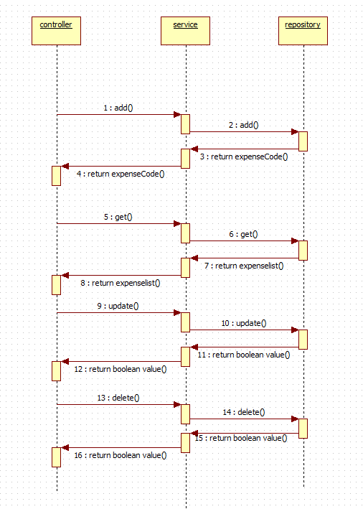

Design Components

List Of UI Components

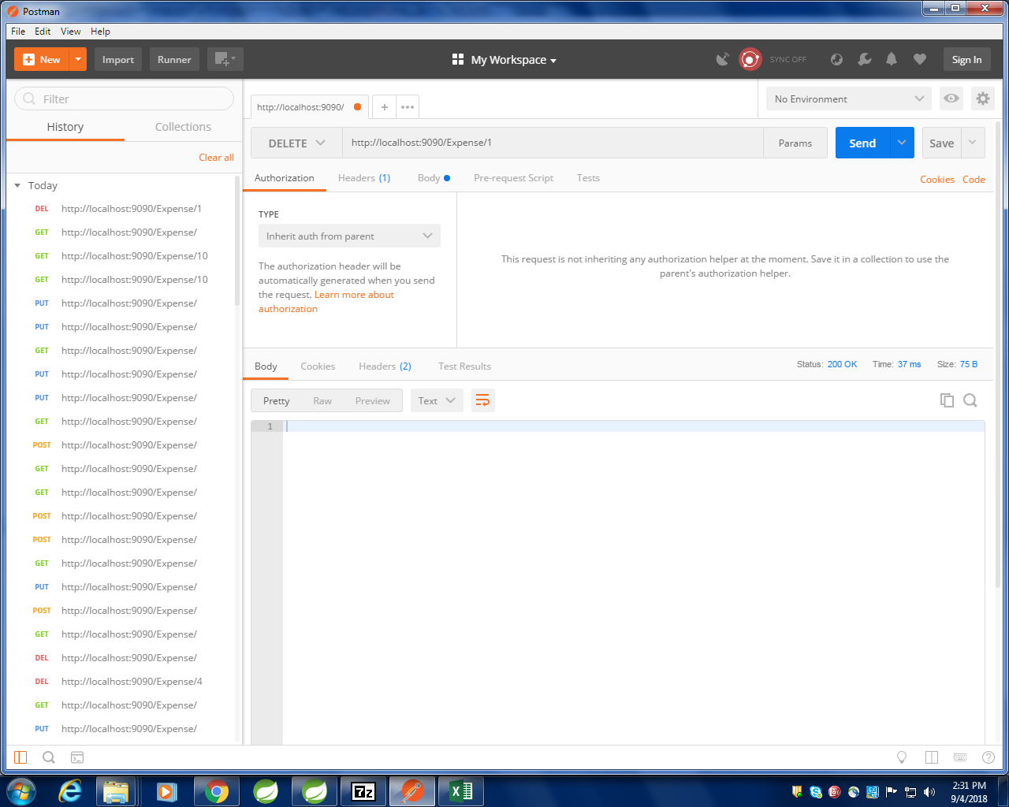

LIST OF DESIGN CLASSES

Sr. No. | LLD Name | Class Name | Method Name | Method Description
1 | Expense Code Module | ExpenseCode | Appropriate getters and setters methods | Getters retrieve the property values and setters set the property values
2 | Expense Code Module | ExpenseCodeController | public void deleteCustomer(@PathVariable Integer expenseCode) | Sets the model attribute.  Calls the Controller method to, delete the Expense Code details in to the database
3 | Expense Code Module | ExpenseCodeServiceImpl | public Integer delete(Integer expenseCode) | Calls the Service layer method to delete the Expense Code details in to the database

Re-Usable Routines/Components
Re-Usable Routines/Components
- CustomizedExceptionHandler
- ErrorDetails
- ExpenseNotFoundException
- Logger properties files

Messages

Configuration Files
#. | Type | Message Text
M1 | Error | Please fill out this field
M2 | Error | Wrong Expense Code :

File Name | Path | Description
application.properties | /Development/Source | To configure database connection and port.
pom.xml | /Development/Source | To configure the dependencies

Crud Matrix Table

# | Table Name | Create | Read | Update | Delete
1 | expensecode | N | N | N | Y

Data Mapping Matrix

Sr. No. | Screen Label | Field Source | Field Type | Data Type | Max Length | Data Flow | Mandatory
1 | Expense Code | ExpenseCode.expenseCode |  | int |  | UI→D | Yes

Legend

UI (User Interface Only)
UI → D (User Interface to Database)

Action Flow Matrix

Sr. No. | Action | Description | Process
1 | On Running the code in the console. | Spring Application starts. | The admin clicks on the Run button in the Spring and console generates with the success message. Then open the Postman.
2 | On changing the action panel to DELETE and entering the details. | The expense code details are deleted from the database. | The expense code is provided in url on which delete is performed.

Stored Procedures

# | Stored Procedure Name  (with Description) | Input/Out Parameters | Type | Size
1. | NA

Program Specification / Pseudo Code

<ACTION: INSERT_FLIGHT_INFORMATION >

Pseudo Code:
- Client Side Scripting:
None

- Server Side Scripting:
BEGIN
Call the Service Layer for deleting the expense code details from the database.
END

Pseudo Code:
14.2 <ACTION: RAISE_REQUISITION >

- Server Side Scripting:
IF Expense Code is Empty
Print Error Message M1
ELSE IF Expense Code is in valid
Print Error Message M2

- Server Side Scripting:
BEGIN
Call public void deleteCustomer(@PathVariable Integer expenseCode) in ExpenseCodeController
BEGIN
Call public Integer delete(Integer expenseCode) in ExpenseCodeServiceImpl class in Service Layer
BEGIN
Call IExpenseCodeDao interface in Dao layer which in turn interact with JPARepository through which data gets deleted for specified expense code
END

Return Integer value to service Layer
END
IF expense code does not exists correct error message id displayed
END

REVISION HISTORY OF THE WORK PRODUCT
<To be maintained by projects>

# | Date | Version # | Section Changed | Details of changes made | Approved By
1
2

